INTRODUCTION
INTRODUCTION

Now a days every user who uses Internet want to search for anything, like Educational colleges, about Information Technology, books, news etc., using Search Engines. This is a needed for everyone. This project “Vertical Search with WebCrawler” searches required result using vertical searching techniques.
In the search engine project the Web crawler will start with some seeds and will select the pages using some filters and policies. For example: if we are to create a blog search engine, the crawler will be programmed to download blog related pages only.
The crawler can be developed using java program. The program will download and index the pages in a database for faster searching. The search in can be developed using web/networking concepts of java. The search engine will accept the search keywords and will search the web pages for the keywords using some search algorithms.
It can search corresponding pages of the given keywords using vertical search technique i.e. if we search a keyword “rose” then it will search only in flowers category.
A User Access the internet and gets the information through different Web sites. The approach to find information from websites is a difficult task. To ease for searching information over the websites by giving search keywords requires software. The search engine software ensures the end user to get the information by accessing the websites specified in the database.

To develop this ’Smart Search’, we are using following Concepts:-
- WebCrawler
- Vertical Search
- String Search

WEB CRAWLER

A web crawler is a program which automatically traverses the web by downloading documents and following links from page to page.

A web Crawler starts with a list of URL’s to visit called seeds. As the Crawler visits these URL’s it identifies all the hyperlinks in the page and adds them to the list of URL’s to visit, called the crawl frontier. URL’s from the frontier are recursively visited according to a set of policies.

The behavior of a Search Engine with Web Crawler is the outcome of a combination of policies:

- Selection policy that states which pages to download

- Politeness policy that states how to avoid overloading websites.

HOW WEB CRAWLERS WORK?

Fundamentals of a Web Crawler

- Download the Web page
- Parse through the downloaded page and retrieve all the links
- For each link retrieved, repeat the process
VERTICAL SEARCH

It’s a technique to search required URLs from the database. In this we can store URL information along with category. It is also known as URL filtering. With this we can save the time and improve search efficiency. Technique used here is DFS(depth First Search).

Eg: If we search “scanner” keyword. Then it can search only in hardware category.

Vertical search engines send their spiders out to a highly refined database, and their indexes contain information about a specific topic. As a result, they are of most value to people interested in a particular area; what’s more, the companies that advertise on these search engines reach a much focused audience. For example, there are search engines for veterinarians, doctors, patients, job seekers, house hunters, recruiters, travelers and corporate purchasers, to name a few.

STRING SEARCH

It’s a technique to search required keyword from the links found by the WebCrawler. In this smart search we can store URL information along with category.

Eg: If we search “scanner” keyword. Then it can search in all the links generated by the web crawler.

Depth First Search (DFS)

Depth first search (DFS) is useful for
- Find a path from one vertex to another
- Whether or not graph is connected
- Computing a spanning tree of a connected graph.
DFS uses the backtracking technique.

Algorithm Depth First Search
Algorithm starts at a specific vertex S in G, which becomes current vertex. Then algorithm traverse graph by any edge (u, v) incident to the current vertex u. If the edge (u, v) leads to an already visited vertex v, then we backtrack to current vertex u. If, on other hand, edge (u, v) leads to an unvisited vertex v, then we go to v and v becomes our current vertex. We proceed in this manner until we reach to "deadend". At this point we start back tracking. The process terminates when backtracking leads back to the start vertex.
Edges leads to new vertex are called discovery or tree edges and edges lead to already visited are called back edges.

DEPTH FIRST SEARCH (G, v)
Input: A graph G and a vertex v.
Output: Edges labeled as discovery and back edges in the connected component.
For all edges e incident on v do
If edge e is unexplored then
w ← opposite (v, e) // return the end point of e distant to v
If vertex w is unexplained then
- mark e as a discovery edge
- Recursively call DSF (G, w)
else
- mark e as a back edge

DFS algorithm used to solve following problems.
Testing whether graph is connected.
Computing a spanning forest of graph.
Computing a path between two vertices of graph or equivalently reporting that no such path exists.
Computing a cycle in graph or equivalently reporting that no such cycle exists.

ALGORITHM DFS_DETECT_CYCLES [G]
For each vertex u in V[G] do
Color [u] = while,
Predecessor [u] = NIL;
time = 0
For each vertex u in V[G] do
if color [u] = while
DFS_visit(u);

The subalgorithm DFS_visit(u) is as follows:

DFS_visit(u)
color(u) = GRAY
d[u] = time = time + 1
For each v in adj[u] do
if color[v] = gray and Predecessor[u] v do
return "cycle exists"
if color[v] = while do
Predecessor[v] = u
Recursively DFS_visit(v)
color[u] = Black;
f[u] = time = time + 1

Correctness
To see why this algorithm works suppose the node to visited v is a gray node, then there are two possibilities:
- The node v is a parent node of u and we are going back the tree edge which we traversed while visiting u after visiting v. In that case it is not a cycle.
- The second possibility is that v has already been encountered once during DFS_visit and what we are traversing now will be back edge and hence a cycle is detected.

Time Complexity
The maximum number of possible edges in the graph G if it does not have cycle is |V| - 1. If G has a cycles, then the number of edges exceeds this number. Hence, the algorithm will detects a cycle at the most at the Vth edge if not before it. Therefore, the algorithm will run in O(V) time.

ORGANIZATION PROFILE

ABOUT ORGANIZATION
First man Software Solutions. Is a cohesive group of software engineering Company engaged in providing quality complete end-to-end IT/software solutions, systems development, software integration and interactive web based solutions? IMPACT, specializes pre-built solutions that clients rapidly customize thus delivering business intelligence right at the customers’ doorsteps.
The Company applies robust and optimal methodologies; state of art technologies with software engineering skills to domain knowledge in creating information technology based solutions of clients in the respective domains.
The Company is awarded prestigious ISO 9001 certification by RINA of Italy, which is recognized in more than 31 countries including the USA, Canada, Japan, Australia and all European countries.
IMPACT, specializing cost effective, yet time bound and high technology solutions, has several offshore IT-Service facilities located in India. These state-of-the-art offshore facilities are home to many software engineers drawn from the finest institutions. The traditional approach of building an internal IT team is time consuming and expensive For almost all clients embarking on IT projects for in house operations, such short-term assignments work well for non-recurring needs, meets project goals and allows regular staff to continue in the core business areas.
IMPACT assembles teams of employees and consultants with the specific expertise required for a project, enabling them in building best breed of approaches, methods, models and tools. It can also help to augment in-house staff and infuse new technology and services into operations. With business strategists, consumer marketing gurus, architects, designers, and senior professional developers - IMPACT can surely provide an expert team to build the optimum solutions.

MISSION
Our mission is to offer cost-effective, superior quality and commercially
viable services and solutions to our clients and partners by evolving into a significant global IT-solution provider.
We shall adhere to strong internal value systems with integrity, fairness and the pursuit of excellence in all our activities. These principles will be visible in our interactions with our clients, partners, associates and employees.

QUALITY FOCUS We are engineers, designers and business people. We work hard, work smart and enjoy helping our customers succeed in this hi-tech marketplace. We believe in the principle: "Do it right, the First Time". Our new employees, too, learn this principle quickly, because we want to give our customers what they want, rather than what we think they should have. The quality effort is backed up by results. We aspire to be a global leader in IT services and part of this mindset is to be a complete IT-solutions and services provider. At IMPACT, target is to set new benchmarks in productivity, customer satisfaction, employee satisfaction, and provide 'zero-defect' solutions. It is this urge to excel that drives us to search for new and better solutions that will support in every aspect of business strategy.

Feasibility Study

Feasibility Study:

The feasibility study is to determine whether the system requested is feasible or not. This is to identify the objectives of a new system. Before solving a problem one must know what the problem is. This phase starts as soon as a user or a member of a particular department recognizes a problem and initiates a request to computerize the existing manual system or to modify the current computerized system.

The study is carried out by a small group of people who are familiar with systems analysis and design process. Fact-finding techniques are used to gather the required information.

The major purposes of this study are given below:

Identify the responsible user and to develop an initial scope of the system.
This may involve conducting a series of interviews to see which users are involved in and which users are affected by the proposed project.

Identify the current deficiencies in the user’s environment. This involves preparing a list of functions that are missing or operating unacceptably in the existing system.

Determine objectives for the new system. This involves preparing a list of existing functions, which are to be re implemented and new functions that are to be added.
Determine whether it is feasible to automate the system. This will involves some approximate estimates of the schedule and cost to build a new system.

The feasibility study of search Engine project covers the major 3 aspects namely:

- Technical Feasibility
- Economical Feasibility
- Operational Feasibility

Technical Feasibility:
The issues related to technical feasibility are little complicated because of the usage of system dependent on websites. Accessing these calls and implementing it in proper way without disturbing the proxy server connection is more important.
The configuration of the internet settings is also another area where it affects the search engine to a greater extent. But with good maintenance of System will take care of the problem.

Operational Feasibility:

As the Search Engine software is developed using state of art, high calibrated, powerful internet settings, it is very much operational with current technologies and practices. In addition, the user interface provided in the will make user / administrator more comfortable with all the complex tools at his easy disposal. Implementation of the search engine software tool in any organization website is very much practical as it doesn’t demand any other external resources or components.

Economical Feasibility:

Economically, this project doesn’t raise any issues, as the project itself is planned or aimed at to get the information from registered web sites. The resources required for this project are bare minimum. The search engine software doesn’t demand any additional equipment.

SOFTWARE REQUIREMENT ANALYSIS

OPERATING SYSTEM
Windows XP Professional

An Exciting New Look

Windows XP professional shows a visual design that combines a sleek look, clean lines, and appealing colors with a task-oriented design and exceptionally streamlined navigation.

The redesign Start menu makes it easier to find important information and to access the programs we use most frequently.

By automatically cleaning up the notification area of the taskbar and grouping related taskbar items, Windows XP makes it easier to switch between programs and to open, view, or close multiple items at the same time.

The Easiest Windows

Windows XP makes it easy to manage all of our information we’ve enhanced the My Documents, My Pictures, and My Music folders to make them more useful. Now whenever we open these folders, we’ll also see handy shortcuts to the most common tasks for documents, pictures, and music.

Integrated support for web publishing means that we can put our documents on the internet and get to them easily from any location.

Windows XP professional also supports integrated CD recording so now we can easily save files to a CD-R of CD-RW drive.

Stay up to Date

Windows Update provides us with critical software updates and hardware support files for Windows XP. And Setup gives us the opportunity to ensure that we have the latest software to install windows quickly and successfully. For corporate customers, there have been great improvements to the system preparation tools as well as unattended setups.

Our computer will be faster and more reliable

Windows XP professional not only starts faster than any previous version of windows, but it also runs our programs more quickly and reliably than ever. If a program becomes unstable, we can close it without having to shutdown windows or lose any of our work.

Get support for the latest hardware and software

Windows XP professional supports a large number of programs and has built-in support for the latest hardware, including DirectX 9 for great multimedia support. When we insert a floppy disk, ZIP disk, CD, or memory card from our digital camera, Windows XP identifies the content (such as pictures, music, of video), and automatically starts the appropriate program. Windows XP professional also supports DVD-RAM drives.

Easily move documents and personal settings to a new computer

If we’ve had a computer for a while, we’ve probably gotten it set up the way we like. Files are organized a certain way, we have bookmarked a long list of favorite web sites, and we’ve customized our desktop just the way we want it.

Those personal settings won’t be wiped out when we buy a new computer with Windows XP. With the Files and Settings Transfer Wizard, it’s simple to move our files and settings from one computer to another.

The wizard is located in the System Tools folder. For a command-line version, that system administrators can use one multiple computers at once, to the User State Migration Tool (USMT) in the Value Add folder.

Surfing the Internet; safe, fast and flexible

Windows XP includes the most secure version of internet explorer to date. Many new features help enhance the security and privacy of information that we send and receive over the internet, while simplifying the daily tasks that we perform. New innovative browser capabilities such as a pop-up blocker, the ability to control plug-ins, and more will let us experience the web exactly the way that we want.

Explore our creative side with photos and videos

Windows XP enhances our ability to share photos and videos with our friends and family. We can easily download pictures from our digital camera into the My Picture folder.
The improved My Picture folder shows thumbnails views of our pictures, so it’s easy to find the ones we want. And the tasks in the My Pictures folder help us publish our favorite pictures to the web or send them through e-mail to quickly share with friends and family. We can even use the Photo Printing Wizard to easily print photos in any size and quantity.
JAVA

Although Java was designed for interpretation, there is technically nothing about Java that prevents on-the-fly compilation of byte code into native code. Sun has just completed its Just In Time (JIT) compiler for byte code. When the JIT compiler is a part of JVM, it compiles byte code into executable code in real time, on a piece-by-piece, demand basis. It is not possible to compile an entire Java program into executable code all at once, because Java performs various run-time checks that can be done only at run time. The JIT compiles code, as it is needed, during execution.

Java, Virtual Machine (JVM)
Beyond the language, there is the Java virtual machine. The Java virtual machine is an important element of the Java technology. The virtual machine can be embedded within a web browser or an operating system. Once a piece of Java code is loaded onto a machine, it is verified. As part of the loading process, a class loader is invoked and does byte code verification makes sure that the code that’s has been generated by the compiler will not corrupt the machine that it’s loaded on. Byte code verification takes place at the end of the compilation process to make sure that is all accurate and correct. So byte code verification is integral to the compiling and executing of Java code.
Simple
Java was designed to be easy for the Professional programmer to learn and to use effectively. If We are an experienced C++ programmer, learning Java will be even easier. Because Java inherits the C/C++ syntax and many of the objects oriented features of C++. Most of the confusing concepts from C++ are either left out of Java or implemented in a cleaner, more approachable manner. In Java there are a small number of clearly defined ways to accomplish a given task.

Object-Oriented
Java was not designed to be source-code compatible with any other language. This allowed the Java team the freedom to design with a blank slate. One outcome of this was a clean usable, pragmatic approach to objects. The object model in Java is simple and easy to extend, while simple types, such as integers, are kept as high-performance non-objects.

Robust:
The multi-platform environment of the Web places extraordinary demands on a program, because the program must execute reliably in a variety of systems. The ability to create robust programs was given a high priority in the design of Java. Java is strictly typed language; it checks our code at compile time and run time.

Java virtually eliminates the problems of memory management and de-allocation, which is completely automatic. In a well-written Java program, all run time errors can –and should –be managed by our program.

SERVLETS & JSP

Architecture of the Servlet Package
The javax.servlet package provides interfaces and classes for writing servlets. The architecture of the package is described below.

The Servlet Interface
The central abstraction in the Servlet API is the Servlet interface. All servlets implement this interface, either directly or, more commonly, by extending a class that implements it such as HttpServlet
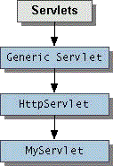
The Servlet interface declares, but does not implement, methods that manage the servlet and its communications with clients. Servlet writers provide some or all of these methods when developing a servlet.

Client Interaction
When a servlet accepts a call from a client, it receives two objects:
- A ServletRequest, which encapsulates the communication from the client to the server.
- A ServletResponse, which encapsulates the communication from the servlet back to the client.
ServletRequest and ServletResponse are interfaces defined by the javax.servlet package.

The ServletRequest Interface
The ServletRequest interface allows the servlet access to:
- Information such as the names of the parameters passed in by the client, the protocol (scheme) being used by the client, and the names of the remote host that made the request and the server that received it.
- The input stream, ServletInputStream. Servlets use the input stream to get data from clients that use application protocols such as the HTTP POST and PUT methods.
Interfaces that extend ServletRequest interface allow the servlet to retrieve more protocol-specific data. For example, the HttpServletRequest interface contains methods for accessing HTTP-specific header information.

The ServletResponse Interface
The ServletResponse interface gives the servlet methods for replying to the client. It:
- Allows the servlet to set the content length and MIME type of the reply.
- Provides an output stream, ServletOutputStream, and a Writer through which the servlet can send the reply data.
Interfaces that extend the ServletResponse interface give the servlet more protocol-specific capabilities. For example, the HttpServletResponse interface contains methods that allow the servlet to manipulate HTTP-specific header information.
JSP Overview
This document is an introduction and reference for the basic syntax of JavaServer Pages (JSP). It provides information about how to use JSP with WebLogic Server. It is not intended as a comprehensive guide to programming with JSP.
What Is JSP?
JavaServer Pages (JSP) is a Sun Microsystems specification for combining Java with HTML to provide dynamic content for Web pages. When you create dynamic content, JSPs are more convenient to write than HTTP servlets because they allow you to embed Java code directly into your HTML pages, in contrast with HTTP servlets, in which you embed HTML inside Java code. JSP is part of the Java 2 Enterprise Edition (J2EE).
JSP enables you to separate the dynamic content of a Web page from its presentation. It caters to two different types of developers: HTML developers, who are responsible for the graphical design of the page, and Java developers, who handle the development of software to create the dynamic content.
Because JSP is part of the J2EE standard, you can deploy JSPs on a variety of platforms, including WebLogic Server. In addition, third-party vendors and application developers can provide JavaBean components and define custom JSP tags that can be referenced from a JSP page to provide dynamic content.
Main Steps for Creating Custom JSP Tags
Perform the following steps to create and use custom JSP tags:
Write a tag handler class. When you use a custom tag in your JSP, this class executes the functionality of the tag. A tag handler class implements one of two interfaces: javax.servlet.jsp.tagtext.BodyTag or javax.servlet.jsp.tagtext.Tag. Your tag handler class is implemented as part of a tag library. Reference the tag library in your JSP source using the JSP <taglib> directive. A tag library is a collection of JSP tags. Include this directive at the top of your JSP source. For more information, see Referencing a Tag Library.
Write the Tag Library Descriptor (TLD). The TLD defines the tag library and provides additional information about each tag, such as the name of the tag handler class, attributes, and other information about the tags. For more information, see Creating a Tag Library Descriptor.
Reference the Tag Library Descriptor in the Web Application deployment descriptor (web.xml). For more information, see Writing Web Application Deployment Descriptors.

JavaServer Page Architecure

Objective
The objective of this section is to provide an overview of the JSP architecture and also the software required for JavaServer Pages.

Application Architecture
As we read earlier JavaServer Pages is a server side technology that dynamically produces web pages. It is an important to note that when a JavaServer Page executes the result that is sent to the browser is just the HTML and not the Java code.
The output of a JSP doesn't have to be HTML - it can be any text stream. So explicitly when a JSP executes the Java code is executed and the result of that execution is sent to the browser. It is up to the browser to deal with that output. There are scenarios where you may want to produce an output that isn't HTML, for example, XML or plain text.
The Application Server is the component that processes, compiles and executes JavaServer Pages. The output of the JSP execution is passed back to the web server which, in turn, sends the result to the browser.
HTML

INTRODUCTION:

HTML stands for hyper text makeup language. It is a language used to create hypertext documents that have hyperlinks embedded in them. We can build web pages. It is only a formatting language and not a programming language. Hyperlinks are underlined or emphasized words or locations in a screen that leads to other documents; WWW is a global, Interactive, dynamic, cross Platform, graphical hypertext information system. The idea behind hypertext is that instead of reading text in rigid linear structure We can easily jump from one point to another. We can navigate through the information based on our interest and preferences.
HTML is a computer language devised to allow website creation. These websites can then be viewed by anyone else connected to the Internet. It is relatively easy to learn, with the basics being accessible to most people in one sitting; and quite powerful in what it allows We to create. It is constantly undergoing revision and evolution to meet the demands and requirements of the growing Internet audience under the direction of the W3C, the organization charged with designing and maintaining the language.

Hypertext is the method by which We move around on the web — by clicking on special text called hyperlinks which bring We to the next page. Markup is what HTML tags do to the text inside them. They mark it as a certain type of text (italicized text, for example). HTML is a Language, as it has code-words and syntax like any other language.

HYPERMEDIA

HTML pages with audio and video files linked to them are called Hypermedia. HTML is platform independent.

HTML IS PLATFORM INDEPENDENT:

If we can access internet, we can access WWW, Irrespective of our operating system and the operating system to the web server. All we require to view and unload the HTML files which are on the “www” are a browser and internet connection.

WEB IS DISTRIBUTED:

The information on the WWW is distributed throughout the world. We can access it with a few mouse clicks. We do not have to store it on our machine. Information on the Web is dynamically updateable. As the information is at the site where it is published, the people who publish it can change it any time.

HTML is a language for describing structured documents, HTML describes the structures of documents - lists, headings, paragraphs Etc. Elements of web documents are labeled through the usage of HTML tags, and it is the tags that describe the documents. Anything that is not a tag is a part of the Document itself.

The Static Web
When the World Wide Web was born, it consisted of static Web sites. Web sites consisted of static documents (mostly HTML pages) that were accessible through Web servers. Users used Web browsers to access these Web sites. A Web browser communicated with a Web server over the Hyper Text Transfer Protocol (HTTP). Using an HTTP request, the browser communicated with the Web server and asked to get access to a certain document. The Web server managed a set of documents stored on a file system. When asked for a document, it would retrieve it and return it within an HTTP response:
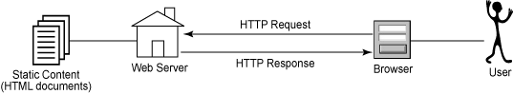

JAVA SCRIPT

A brief about Java Script:

Java Script is object based scripting language for client and server applications developed jointly by Sun and Netscape and it meant for the WWW. A scripting language is a simple programming language designed to enable programmers to write useful programs quickly. A script is similar to a macro, which tells a program how to perform a specific procedure.
There are two types of Java Script:

1. Navigator Java Script, also called client-side Java Script.
2. Live Wire Java Script also called server-side Java Script.
Features of Java Script:

Java Script is a Loosely Typed Language

Java Script is very flexible compared to Java. We need not to specify the data type of the variable while declaring it. Also, We need not declare variables explicitly. It is perfectly legal to declare variable as and when We require them.
Java Script is an Object-Based Language

Java Script is an object-based language. We can work with objects that encapsulate data (properties) and behavior (methods). However Java Script object model is instance-based and there is no inheritance. This is the basic difference between an object oriented and an object based language.

Java Script is embedded into HTML

Java Script code is usually embedded into an HTML document and is executed within them. By itself Java Script has no user interface. It relies on HTML to provide the means of interaction with the user. Most of Java Script objects have HTML tags they represent. Java Script extends the capabilities of HTML by providing events to HTML tags and provides event driven code to execute it.
Java Script is interpreted at runtime by the browser before it is executed. It is not compiled into a separate program like an .exe but remains part of the HTML file.

JDBC CONNECTIVITY
A JDBC driver is a class that implements the JDBC Driver interface and understands how to convert program (and typically SQL) requests for a particular database. Clearly, the driver is what makes it all work. There are four different driver types, which are discussed in the JDK (Java Development Kit) documentation at JDBC Driver Types. This course uses type 4 drivers because of their nearly zero installation requirements and dynamic nature. Another driver type may make more sense for your particular project. Most database vendors now provide drivers to implement the JDBC API for their particular systems. These are generally provided free of charge. Third party drivers are also available, ranging in cost from free to very expensive. For links to JDBC driver resources, see Specific Information and the other Resources.

JDBC 1.0
The JDBC 1.0 API provided the basic framework for data access, consisting primarily of the following interfaces and classes:
• Driver
• DriverManager
• Connection
• Statement
• PreparedStatement
• CallableStatement
• ResultSet
• DatabaseMetaData
• ResultSetMetaData
• Types
As you will see in this course, you pass a Driver to the DriverManager and then obtain a Connection. A Statement, PreparedStatement, or CallableStatement is then created and used to update the database or execute a query. A query returns a ResultSet containing the requested data, which is retrieved by Type. DatabaseMetaData and ResultSetMetaData classes are available to provide information about a database or a ResultSet.

JDBC 2.0
The JDBC 2.0 API is broken into two parts: the core API, which this course discusses, and the JDBC 2.0 Optional Package. In general, the JDBC 2.0 core API adds a few more classes, but is primarily concerned with performance, class enhancements and functionality, and the new SQL3 (also known as SQL-99) data types.
The new functionality in the core API includes scrollable result sets, batch updates, programmatic inserts, deletes, and updates, performance hints, character streams for streams of internationalized Unicode characters, full precision for java.math.BigDecimal values and support for time zones in Date, Time, and Timestamp values. At the time this course was prepared; the JDBC 3.0 draft was under review and planned to be included in the 1.4 release of the JDK.
INTRODUCTION TO ORACLE 8i

Oracle is popular relational database software available on a wide number of platforms. Oracle provides complete control organizing the data storage to obtain very good performance using indexing, clustering. It supports very powerful SQL, which is complete starting from creation of the database.

INTRODUCTION TO SQL

Structured Query Language:
It is a tool of communication between a user and RDBMS. SQL is a simple and powerful language in the sense that most of the operations in RDBMS using SQL. The important feature is, it is not procedural, and advantages of using non procedural language are

- Reduction of code.
- Simplicity in writing.
- Ease in writing code.
- Reduction in maintaining the software.
SQL is the language used to access data with in oracle database developed in a prototype RDBMS, ‘System R’, by IBM in mid 1970’s. Oracle Corporation introduced the first commercially available implementation of SQL as a standard language for RDBMS, in October 1986. SQL is made of three sublanguages.

DDL: Definition Language consists of commands to create the objects, such as tables, alter, drop, grant, revoke etc.
DML: Data Manipulation Language is used for querying, inserting, deleting and updating of information stored in the database.
DCL: Data Control Language is used for controlling data and access to the database in multi-user environment for security purpose. The DCL is used for giving access rights to different users.

SQL*PLUS

SQL*PLUS is a software product from oracle corporation that allows users to interactively use the SQL commands , produce formatted reports and Support written command-procedures to access oracle database. It accepts three types of commands namely SQL commands, SQL plus commands, formats, perform calculations on store and print query results in the form of reports.

CHOOSING ORACLE AS BACK END

Oracle database was designed based on the relational data model and users, Structured Query Language (SQL) as its query language. Some of the major advantages of the oracle database provide are as under

- Oracle is an “open” system and adheres to the industry accepted standards for data access language (SQL).
- Oracle supports database of all sizes, from several bytes to Giga Bytes in size.
- Oracle supports a large number of concurrent users. It minimizes data connections and guarantees data occurrence.

- Oracle supports a true client/server environment. It enables processing to be split between the database server and the client application programming.
- A data model that is easily understood and visualized, integrity laws those are easy to develop and understand to project data and its structures.
- Reduced data storage and redundancy.
- Independence of physical data storage and logical database structure.

Oracle system architecture:

Oracle processing capability comes from its primary structures and processes. Oracle uses two main memory structures in its operations. The system global area is a memory structure that contains data and control information for one oracle instance. The SGA and server background process constitute an oracle instance. The second main memory structure is the Program Global Area (PGA). The PGA contains data control information for a server process. The PGA is created when a server is started.

TOMCAT WEB SERVER
Introduction
In many production environments it is very useful to have the capability to manage your web applications without having to shut down and restart Tomcat. This document is for the HTML web interface to the web application manager.
The interface is divided into five sections:
- Message - Displays success and failure messages.
- Manager - General manager operations like list and help.
- Applications - List of web applications and commands.
- Install - Installing web applications.
- Server Information - Information about the Tomcat server.
Message
Displays information about the success or failure of the last web application manager command you performed. If it succeeded OK is displayed and may be followed by a success message. If it failed FAIL is displayed followed by an error message. Common failure messages are documented below for each command. The complete list of failure messages for each command can be found in the manager web application documentation
Applications
The Applications section lists information about all the installed web applications and provides links for managing them. For each web application the following is displayed:
- Path - The web application context path.
- Display Name - The display name for the web application if it has one configured in its "web.xml" file.
- Running - Whether the web application is running and available (true), or not running and unavailable (false).
- Sessions - The number of active sessions for remote users of this web application. The number of sessions is a link which when submitted displays more details about session usage by the web application in the Message box.
- Commands - Lists all commands which can be performed on the web application. Only those commands which can be performed will be listed as a link which can be submitted. No commands can be performed on the manager web application itself. The following commands can be performed:
  - Start - Start a web application which had been stopped.
  - Stop - Stop a web application which is currently running and make it unavailable.
  - Reload - Reload the web application so that new ".jar" files in /WEB-INF/lib/ or new classes in /WEB-INF/classes/ can be used.
  - Remove - Stop and then remove this web application from the server
Installation
If the Host is configured with unpackWARs=true and you install a war file, the war will be unpacked into a directory in your Host appBase directory.
If the application war or directory is installed in your Host appBase directory and either the Host is configured with autoDeploy=true or liveDeploy=true, the Context path must match the directory name or war file name without the ".war" extension.
For security when untrusted users can manage web applications, the Host deployXML flag can be set to false. This prevents untrusted users from installing web applications using a configuration XML file and also prevents them from installing application directories or ".war" files located outside of their Host appBase.
XML
This page covers the basics of XML. The goal is to give you just enough information to get started, so you understand what XML is all about. (You'll learn about XML in later sections of the tutorial.) We then outline the major features that make XML great for information storage and interchange, and give you a general idea of how XML can be used. This section of the tutorial covers:
XML is a text-based markup language that is fast becoming the standard for data interchange on the Web. As with HTML, you identify data using tags (identifiers enclosed in angle brackets, like this: <...>). Collectively, the tags are known as "markup".
But unlike HTML, XML tags tell you what the data means, rather than how to display it. Where an HTML tag says something like "display this data in bold font" (<b>...</b>), an XML tag acts like a field name in your program. It puts a label on a piece of data that identifies it (for example: <message>...</message>).
In the same way that you define the field names for a data structure, you are free to use any XML tags that make sense for a given application. Naturally, though, for multiple applications to use the same XML data, they have to agree on the tag names they intend to use.
Here is an example of some XML data you might use for a messaging application:
<message>
<to>you@yourAddress.com</to>
<from>me@myAddress.com</from>
<subject>XML Is Really Cool</subject>
<text>
How many ways is XML cool? Let me count the ways...
</text>
</message>

PROBLEM ANALYSIS

PROBLEM ANALYSIS

EXISTING SYSTEM:

The current practice for finding desired information in web is to use any of the famous search engines with the URL. This approach is pretty efficient for searching large parts of the Web, but it is basically static. The actual search is performed on the server on all the data stored in the index. Results are not guaranteed to be valid at the time the URL is issued (since many search sites may take up to one month for refreshing their full Web).
Disadvantages:
Since the pages are retrieved from the search engine server(s) the results may not be valid at the time of the URL is used.
- The user cannot control the search process.
- The user cannot search from a desired search point.

PROPOSED SYSTEM:
In contrast, the Vertical Search with Web Crawler actually searches the data at the time keyword and the category is issued. Once these are given perfect match is searched from the system which involves Vertical search with Web Crawling technique that guarantees valid results, and preferable to static search for discovering information in small and dynamic sub Webs. String Search is finally in to action to visualize the result page.

Advantages:
- Rules can be generated that are easy to interpret and understand.
- They scale well for large databases because the tree size is independent They are easy to use and are efficient.
- Of database size.
- Each tuple in the database must be filtered through the tree.
Trees can be constructed for data with many attributes.

UML APPROACH:
UML stands for Unified Modeling Language. UML is a language for specifying, visualizing and documenting the system. This is the step while developing any product after analysis. The goal from this is to produce a model of the entities involved in the project which later need to built. The representation of the entities involved in the project which later need to be built. The representation of the entities that are to be used in the product being developed needed to be designed.

The goal of UML is to produce a standard notation that can be used by all object-oriented methods and to select and integrate the best elements of notations. The UML consists of a number of graphical elements that combine to form diagrams. Because it’s a language, the UML has rules for combining these elements.

Software design is a process that gradually changes as various new, better and more complex methods with a broader understanding of the whole problem in general come in to existence. There are various kinds of methods in software design. There are as follows

- Use case diagrams
- Class diagram
- Object diagram
- Sequence diagram
- Deployment diagram
- Activity diagram
- State chart diagram

Use case diagram:
Use case diagrams model behavior with in a system and helps the developers understand of what the use of required. The stick man represents what’s called an actor.

An actor represents an outside entity-either human or technological. In this example human (stick man). Notice and curved rectangle on the diagram this represents the system boundary everything inside that is part of that system, and everything out side are actors (basically not part of system).

Use case diagrams can be useful for getting an overall view of the system and clarifying that can do and more importantly what they want to do

Use case diagram consists of use cases and actors and shows the interaction between the use case and actors

- The purpose is to show the interactions between use case and actor
- To represent the system requirements from users perspective.
- It must be remembered that the use cases are the functions that are to be performed in the module.
- An actor could be end-user of the system or an external system.

Class Diagram:
A class is a category or group of things that have similar attributes and common behaviors’. Class diagrams are used to describe the structure of the system. Classes are abstraction that specifies the common structure and behavior of a set of objects. Objects are instances of classes that are created, modified, and destroyed during the execution of the system. An object has state that includes the values of its attributes and it links with other objects.

Object Diagram:
An object is an instance of a class a specific thing that has specific values of the attribute and behavior.

Sequence Diagram:
Sequence diagrams are used to formalize the dynamic behavior of the system and to visualize the communication among objects. They are useful for identifying additional objects that participate in the use cases. We call the objects involved in the use case participating objects.
State chart diagram:
State chart diagram describes dynamic behavior of an individual object as a number of states and transitions between these states. A state represents a particular set of values for an object. Given a state, a transition represents a future state that object can move to and the conditions associated with the change of the state.
Activity diagram:
An activity diagram describes the behavior of the system in terms of activities. Activities are modeling an element that represents the execution of a set of operations. The completion of these operations triggers a transition to another activity. Activity diagrams are similar to flow chart diagrams in that they can be used to represent control flow and data flow.
Deployment diagram:
The deployment diagram shows the physical architecture of a computer based system. It can depict the computer and devices, show their connections with one another and show the software that sits on each machine. Each computer is represented by a cube.

REQUIREMENT SPECIFICATION

Functional Requirements:
- The system provides user friendly Graphical User Interface (GUI).
- It should allow the user to specify the URL.
- The system should explicitly prompt the user to provide the Searching parameters, if not provided the system should make use of the default parameters.
- The system must run in multithreaded mode
- The system should not Search block listed URLs and bad extension files

Non Functional Requirements:

Nonfunctional requirements describe aspects of the system that are not directly related to the functional behavior of the system. Nonfunctional requirements include a broad variety of requirements that apply to many different aspects of the system starting from usability to performance. The various categories of nonfunctional requirements are:
      - Usability
      - Reliability
      - Performance
      - Supportability
      - Error handling and extreme conditions
1. Usability:
It is the ease with which a user can learn to operate, prepare inputs for, and interpret outputs of a system or component. Usability requirements include conventions adopted by the user interface, and the level of user documentation. This application is useful in maintaining student details, attendance and marks.

2. Reliability:
It is the ability of the system to perform its required functions, understand conditions for a specified period of time. Reliability requirements include an acceptable mean time to failure and the ability to detect specified faults. The software is thoroughly tested for errors and performance.

3. Performance:
The performance requirements are concerned with quantifiable attributes of the system such as response time, throughput, availability and accuracy. It performs accurate calculations and the results are displayed with in no time.

4. Supportability:
Supportability requirements are concerned with the ease of changes to the system after development, including adaptability, maintainability. This application can run with minimum hardware requirements and can be easily maintained.

5. Error handling:
In this web based application we create pages to take input from user and store it in the database. If the user enters any branch, course, student which already exists in the database then it displays the user an appropriate message. The overall application is built in a very user friendly way so that the user without any computer knowledge can operate the system.

Pseudo Requirements:
The design phase consists of following steps
- Designing the pages for taking inputs.
- Identifying the attributes.
- Normalization into third normal form.
- Identifying the use cases
- Identifying the scenarios

OBJECT DESIGN

UML APPROACH:

UML stands for Unified Modeling Language. UML is a language for specifying, visualizing and documenting the system. This is the step while developing any product after analysis. The goal from this is to produce a model of the entities involved in the project which later need to built. The representation of the entities involved in the project which later need to be built. The representation of the entities that are to be used in this product being developed needed to be designed.

The goal of UML is to produce a standard notation that can be used by all object-oriented methods and to select and integrate the best elements of notations. The UML consists of a number of graphical elements that combine to form diagrams. Because it’s a language, the UML has rules for combining these elements.

Software design is a process that gradually changes as various new, better and more complex methods with a broader understanding of the whole problem in general come in to existence. There are various kinds of methods in software design. There are as follows

- Use case diagrams
- Class diagram
- Object diagram
- Sequence diagram
- Deployment diagram
- Activity diagram
- State chart diagram

Use case diagram:
Use case diagrams model behavior with in a system and helps the developers understand of what the use of required. The stick man represents what’s called an actor.
An actor represents an outside entity-either human or technological. In this example human (stick man). Notice and curved rectangle on the diagram this represents the system boundary everything inside that is part of that system, and everything out side are actors (basically not part of system).
Use case diagrams can be useful for getting an overall view of the system and clarifying, who can do and more importantly what they want to do
Use case diagram consists of use cases and actors and shows the interaction between the use case and actors

- The purpose is to show the interactions between use case and actor
- To represent the system requirements from users perspective.
- It must be remembered that the use cases are the functions that are to be performed in the module.
- An actor could be end-user of the system or an external system.

Class Diagram:
A class is a category or group of things that have similar attributes and common behaviors’. Class diagrams are used to describe the structure of the system. Classes are abstraction that specifies the common structure and behavior of a set of objects. Objects are instances of classes that are created, modified, and destroyed during the execution of the system. An object has state that includes the values of its attributes and it links with other objects.
Object Diagram:
An object is an instance of a class a specific thing that has specific values of the attribute and behavior.

Sequence Diagram:
Sequence diagrams are used to formalize the dynamic behavior of the system and to visualize the communication among objects. They are useful for identifying additional objects that participate in the use cases. We call the objects involved in the use case participating objects.

State chart diagram:
State chart diagram describes dynamic behavior of an individual object as a number of states and transitions between these states. A state represents a particular set of values for an object. Given a state, a transition represents a future state that object can move to and the conditions associated with the change of the state.

Activity diagram:
An activity diagram describes the behavior of the system in terms of activities. Activities are modeling an element that represents the execution of a set of operations. The completion of these operations triggers a transition to another activity. Activity diagrams are similar to flow chart diagrams in that they can be used to represent control flow and data flow.

Deployment diagram:
The deployment diagram shows the physical architecture of a computer based system. It can depicts the computer and devices, show their connections with one another and show the software that sits on each machine. Each computer is represented by a cube.
SCENARIO:

1. User’s search process:

Use Case Name : | User
Actors Instances : | User  System
Entry Condition: | User opens the Searching page
Flow of Events : | 1)User inputs the search keywords  and category.  2)URLs are filtered  3)crawling of URLs takes place  4)links are displayed  5)The keyword is searched  6)The result page is displayed
Exit Condition: | User Exits from the page
2. Add URL process:

Use Case Name : | Add URL
Actors Instances : | user  system
Entry Condition: | User opens the Add Url page
Flow of Events : | - Enter URL  - Enter Category  - Enter Title  4)Enter Description  5)Submit
Exit Condition: | User Exits from the page
USE CASES:
1. Use case diagram for USER’S search:

Input keyword & category
View URLs
User
Filter URL
Crawl URL
Open links
Search keywords
System

2. Use case Diagram for ADD URL:

Enter URL
Enter category
Enter title
Enter description
User
URL notification
Category notification
System

OBJECT MODEL
CLASS DIAGRAM:
Class Diagrams are used to represent object models during development. The relationships between the classes can be explained by the Associations, Aggregations and by Inheritance between them.
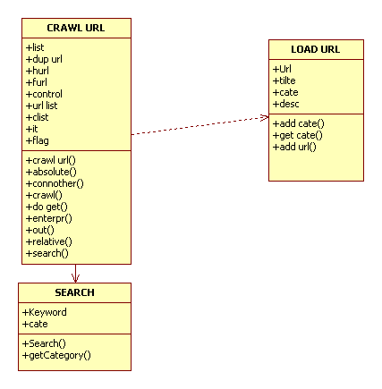

SEQUENCE DIAGRAM:
1. USERS SEARCH
: user
: user
seach links
seach links
URLs
URLs
URLs
URLs
links
Links
keyword
Keywords
1: i/p keyword category
2: filter
3: crawl
4: open
5: search
6: return results

2. ADD URL

: user
: user
URL
URL
category
Category
title
Title
descripti
Description
notify
Notify
1: enter
2: enter
3: enter
4: enter
5: submit
6: acknowledgement

DYNAMIC MODEL
STATE CHART DIAGRAM
1.USER SEARCH :

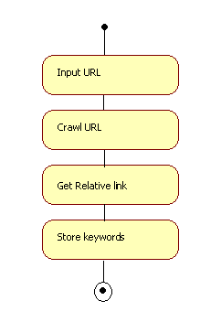

2. ADD URL:

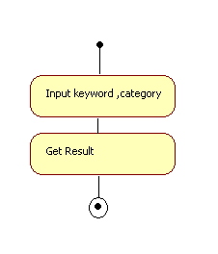

ACTIVITY DIAGRAM
1.USER SEARCH:

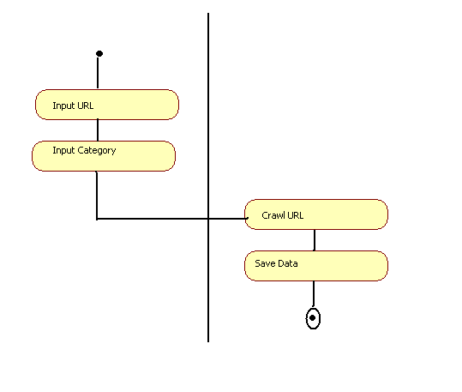

2.ADD URL:
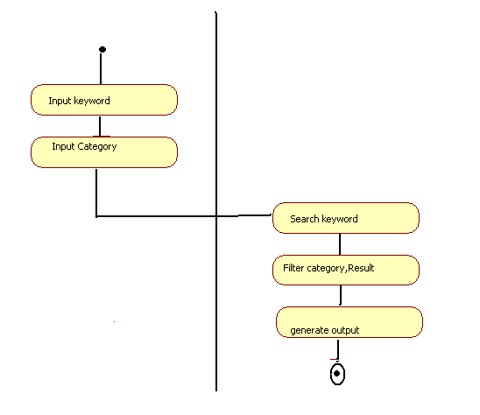

COMPONENT DIAGRAM

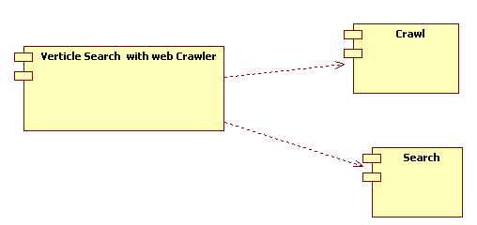

DEPLOYMENT DIAGRAM

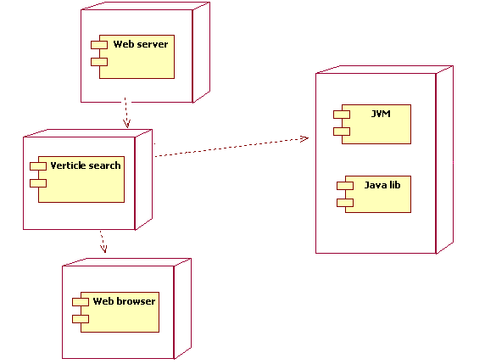

SYSTEM DESIGN
SYSTEM DECOMPOSITION

System Design
System Design is the process, which involves conceiving planning and carrying out the plan by generating the necessary reports and inputs. In other words design phase acts as a bridge between the software requirement specification and implementation phase, which satisfies those requirements. System Design is the transformation of the analysis model into a system design model.
The design of a system is correct if a system built precisely according to the requirement of that system. Design should be clearly verifiable, complete and traceable. The goal is to divide the problem into manageably small modules that can be solved separately. The different modules have to cooperate and communicate together to solve the problem.
The complete project is broken down into different identifiable modules. Each module can be understood separately. All the modules at last are combined to get the solution of the complete system.
Design Goals
The definition of design goals is the first step of system design. In our proposed system the goals identified are reliability, fault tolerance, security and modifiability. “Vertical Search with Web Crawler” should be secure and can be modified later by any software developers.
Performance criteria
The Proposed system “Vertical Search With Web Crawler” should have fast response while users should not wait for longer time for the results. The time of click and wait should be decreased.
Dependency criteria
The proposed system must handle both high level exceptions with appropriate alert messages.
Cost criteria
It includes development cost, deployment cost, maintenance cost and administration cost. As the proposed system will be developed using software, which is affordable , hence it can be developed with minimum cost.
Maintenance criteria
The proposed system can be easily maintained by the user. Maintenance costs require performing enhancements to the system.
End User criteria
The proposed system supports the work of all the users throughout the world. Hence it should be kept into the consideration that every customer can easily interact with the system

DATABASE DESIGN
INTRODUCTION

A Database Management System (DBMS) is a collection of interrelated data and a set of programs to access those data. The collection of data, usually referred to as the database contains information relevant to an enterprise.
The primary goal of DBMS is to provide a way to store and retrieve to as the database information that is both convenient and efficient.
A Database consists of some collection of persistent data that is used by the application systems of some given enterprise.

Functions of DBMS

DBMS includes support for the following aspects.
      - Data Definition
      - Data Manipulation
      - Data Security and Integrity
      - Data recovery and Concurrency
      - Data Dictionary
      - Performance
Advantages of Database

- Redundancy can be reduced
- Inconsistency can be avoided
- Data can be shared
- Standards can be enforced
- Security restrictions can be applied
- Integrity can be maintained
A database System provides the user with an abstract view of the data. The system hides details of how the data are stored and maintained.

Conceptual Modeling

Introduction: E-R Diagram
Entity-Relationship model is belongs to a class of data models know as extended of semantic model. Entity-Relationship model perceives the real world as consisting of basic objects, called entities, and relationships among these objects. It was developed to facilitate database design by allowing specifications of an enterprise schema, which represents the overall logical structure of the database. The semantic aspect of the model lies in its representation of the meaning of the data.
Entity-Relationship model employs three basic notions
      - Entity sets
      - Relationship sets and
      - Attributes
Entity: An entity is a thing of object in the real world that is distinguishable from all other objects.
Attribute are descriptive properties possessed by each member of an entity set.
An entity set is a set of attributes of the same type that share the same properties, or attributes.
Scalar values represent the smallest semantic unit of data, in the sense they are atomic. They are non-decomposable units of data.
Domain is the named set of scalar values all of the same type. They are the permitted set of values for an attitude.

A Relation, R on a collection of domains D1, D2, D3… Dn consists of two parts, a heading and a body. In terms of the tabular representations of a relation, the heading is the row of column heading and the body is the set of data rows.
A tuple corresponds to a row of a table and an attribute to a column.
Properties of a relation
- There are no duplicate tuples.
- Tuples are unordered, top to bottom.
- Attributes are unordered, left to right.
- All attributes values are atomic.

All attributes values are atomic at every row and column position with in the table, there is always exactly one value, never a collection of several values. This can be stated as that the relations should not contain repeating groups. A Relation satisfying this condition is said to be normalized or equivalently first normal form.
A Relation database is a database that is perceived by the user as a collection of normalized relations. Perceived by the user refers to the conceptual level of the system.

A Relationship is an association among several entities. A Relationship set is a set of relationships of the same type.
A Key is that which identifies a set of attributes that suffice to distinguish entities from each other. Key also help uniquely identify relationships, and thus distinguish relationships from each other.
A Super key is a set of one or more attributes that taken collectively allows to identify uniquely an entity in the entity set.
Candidate keys are those super keys for which no proper subset is a super key.
Primary key is a candidate key that is chosen as the means of identifying entities with in an entity set.
In addition to entities and relationships, E-R model represents certain constraints to which the database must confirm. A database management system enforces integrity rules in order the constraints in the real world are exactly followed.
Integrity constraints ensure that changes made to the database by authorized users do not result in a loss of data consistency. Thus integrity constraints guard against the accidental damage to the database.
Two forms of integrity constraints in the E-R model are:
- Key declarations-certain form a candidate key for a given entity set.
- Mapping cardinalities, which express the number of entities to which another entity can be associated via relationship set.
Domain constraints are the most elementary form of integrity constraints. They are tested easily by the system whenever a new data item is entered into the database.
The structure of the Primary key for the relationship set depends on the mapping cardinality of the relationship set.

Entity Relationship Diagrams
- Rectangles are used to represent entity sets in an E-R diagram.
- Ellipses are used to represent attributes.
- Diamonds are used to represent relationships sets.
- Lines link attributes to entity sets and entity sets to relationship sets.
- Double ellipses represent multi-valued attributes.
- Dashed ellipses denote derived attributes.
- Double lines indicate total participation of an entity set in a relationship set.
- Double rectangle represents weak entity sets.

RELATION MODEL
The relation model uses a collection of tables to represent both data and relationship among those data. Each table has multiples columns and each column has a unique name.
The relationship model is an example of a record-based model. Record-based models are so named because the database is structured in fixed-format records of several types. Each table contains records of a particular type. Each record type defines a fixed number of fields or attributes. The columns of the table correspond to the attributes of the record type.
The Relation model hides low-level implantation details from database develops and users.
The Relational model requires the domain of all attributes be atomic. A domain is atomic if elements of the domain are considered to be indivisible units.
A Relation schema derived from and E-R schema may include among its attributes the primary key of another relation schema, which is called a foreign key from the earlier schema referencing the later relation schema.
Schema diagrams can depict a database schema along with primary key and foreign key dependencies pictorially. Each relation appears as above with the attributes inside it and the relation name above it. If there are primary key attributes are represented above a horizontal line drawn across the box.

Reduction of E-R Schema to Tables
A database that confirms to the E-R database schema can be represented by a collection of tables. For each entity set and for each relationship set in the database there is a unique table to which the name of the corresponding entity set or relationship set can be assigned.
As the E-R model and the relational model are abstract, logical representations of the real world enterprises and they employ similar design principles an E-R design can be converted into a relational design.

E-R DIAGRAM
Entities and Attributes:

The basic object that the ER model represents is an entity, which is a “thing” in the real world with an independent existence. An entity may be an object with a physical existence. Each entity has attributes-the particular properties that describe it.

Composite Attributes:

Composite attributes can be divided into smaller subparts, which represent more basic attributes with independent meanings. Attributes that are not divisible are called simple or atomic attributes.

Multi valued Attributes:
An attribute can have a set of values for the same entity are said to be the multi valued attributes.
Key Attribute of an Entity:

An important constraint on the entities of an entity type is key or uniqueness constraint on attributes. An entity type usually has an attribute whose values are distinct for each individual entity in the entity in the entity set. Such an attribute is called a key attribute, and its values can be used to identify each entity uniquely.

Degree of Relationship Type :

The degree of a relationship type is the number of participating entity types. A relationship of degree two is called binary, and one of degree two is called ternary.

Cardinality Ratios of Binary Relationships:

The cardinality ratio for a binary relationship specifies the maximum number of relationship instances that an entity can participate in. the possible cardinality ratios for binary relationship types are 1:1, 1:N, N:1, M:N.

Weak Entity Types:

Entity types that do not have key attributes of their own are called weak entity types. Regular entity types that do have a key attributes are called strong attributes. A weak entity type normally has a partial key.
The relationship type that relates a weak entity types to its owner is called identifying relationship.

Weak entity types are distinguished by being placed in double rectangles and by having their identifying relationships placed in double diamonds, as illustrated by the DEPENDENT entity type and the DEPENDENTS_OF identifying relationship type. The partial key of the weak entity type is underlined with a dotted line.

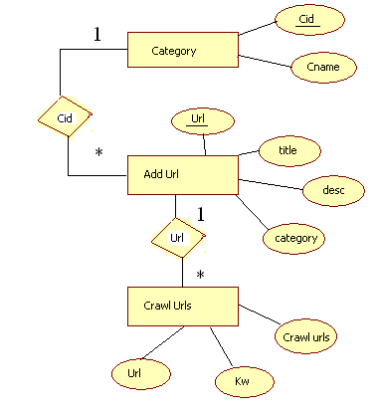
DATA DICTIONARY

Normalization

Introduction
Relational databases a form of database specification based upon the mathematical concept of a relation. The mathematical nature of the concept is, however, not necessary to its appreciation and database may be regarded as composed of a number of rectangular tables, each expressing one relation.

Normalization is carried out for three reasons:
- To secure the data so that any pertinent relationship between entities can be represented.
- To simplify the maintenance of the data through updates, inserts and deletions.
- To reduce the need to restructure or re-organize data when new application requirements arise.

Verification Process

a) Through First Normal Form

First normal form is achieved when a record is designed to be of fixed length. This is accomplished by removing the repeating group and creating a separate file or relation containing the repeating group. The original and new records are interrelated by a common data item.

b) Through Second Normal Form

Second normal form is achieved when a record is in the first normal form and each item in the record is fully dependent on the primary record key for identification data item is functionally dependent if its value is uniquely associated with a specific data items .To achieve second normal form, every data items in the record that is not dependent on the primary key of the record should be removed and used to form a separate relation.

c) Through Third Normal Form

Third normal form is achieved when transitive dependencies are removed from a record designed conversion to third normal form removes the transitive dependencies by splitting the relation into two separate relations.

d) Through BCNF

A relation is said to be in the BCNF if determinate is a candidate key. Relations in 3NF can also have anomalies. Relations in BCNF have no anomalies regarding functional dependencies and this seemed to have put the issue of modification anomalies to rest. However it was soon discovered that anomalies could arise from situations other than functional dependencies. The fourth, fifth and domain key normal forms were proposed to overcome these anomalies.

e) Through Fourth Normal Form

Fourth normal form is achieved when multivalued dependencies are removed from a record designed conversion to fourth normal form removes the multivalued dependencies by taking multivalues and decomposing into another relation with atomic values.

f) Through Fifth Normal Form

Fifth normal form is achieved by removing join dependencies.
DATABASE TABLES

Category Table:

Name | Type | Constraint
CATEGORY_ID | varchar2(20) | Primary Key
CATEGORY_NAME | varchar2(20)

Addurl Table:

Name | Type | Constraint
URL | varchar2(100) | }Primary Key
CATEGORY_ID | varchar2(20) | }Primary Key
TITLE | varchar2(20)
DESCRIPTION | varchar2(500)

Crawledurls Table:

Name | Type | Constraint
URLS | varchar2(100)
CATEGORY_NAME | varchar2(100)
KW | Varchar2(999)

SELECTED SOFTWARE
HARDWARE ENVIRONMENT:

Hardware Requirements
Scenario | Required Processor | Recommended Processor | Required RAM | Recommended RAM
Client (Windows Forms and Windows Services) | Pentium 90 MHz* | Pentium 90 MHz or faster | 32 MB* | 96 MB or higher
Server | Pentium 133 MHz* | Pentium 133 or faster | 128 MB* | 256 MB or higher
*Or the minimum required by the operating system, whichever is higher.
SOFTWARE ENVIRONMENT

Software Requirements
Presentation Layer | HTML, DHTML, JavaScript, XML
Network Layer | TCP/IP
Web Server Layer | Tomcat5.5, Servlets, JDBC, JSP,
Language Specification | Java
Web Technology | HTML
Databases | Oracle8i
Operating Systems | Windows 2000, Windows NT 4.0, Windows 9x

SAMPLE CODING
SAMPLE CODING
SEARCH (main)-frame.html
<html>
<head><title></title></head>
<frameset cols="70%,30%" BORDER=0>
<frame src="./VSEARCH-1.jsp">
<frame src="VSEARCH-2.html" TARGET="WINDOW-1" SCROLLING=NO>
</frameset>
</html>

VSEARCH-1.HTML
<!DOCTYPE html PUBLIC "-//W3C//DTD XHTML 1.0 Transitional//EN" "http://www.w3.org/TR/xhtml1/DTD/xhtml1-transitional.dtd">
<html xmlns="http://www.w3.org/1999/xhtml">
<head>
<meta http-equiv="Content-Type" content="text/html; charset=iso-8859-1" />
<title>Untitled Document</title>
<style type="text/css">
<!-- body,td,th { font-size: 10px; }
.style2 { font-size: 16px; color: #9933FF; font-weight: bold; }
.style3 {font-size: 15px}
.style5 {color: #66FF99}
-->
</style></head>
<script language="javascript">
function check()
{ var keyword=document.form1.keyword.value;
if(keyword.length==0)
{ alert("Please enter keyword");
return false; }
return true; }
</script>
<body>
<img src="images/search.gif" width="100" height="100" align="left"/>
<img src="images/vs.jpg" width="196" height="137" border="2" style="border-collapse:separate" style="border-color:#FFFFCC" align="right" />
<marquee behavior="alternate" scrollamount="3" direction="right"><img src="images/directory_giff.jpg" width="130" height="80"/></marquee>
<p>&nbsp;</p> <p>&nbsp;</p>
<marquee align="baseline" bgcolor="9933##" height="30" direction="right" hspace="30" scrollamount="3" behavior="alternate" vspace="20 "style="border:groove"><H2 class="style5">VERTICAL SEARCH WITH WEB-CRAWLER </H2>
</marquee>
<p>&nbsp;</p>
<form id="form1" name="form1" method="post" action="" onsubmit="return check()">
<p align="center">
<label for="textfield">
<span class="style2"><img src="images/web1.bmp" />SEARCH KEY WORD</span>
<input name="keyword" type="text" id="textfield" size="30" maxlength="40 " />
&nbsp;&nbsp;</label>
<span class="style3">
<label for="label3"></label>
</span> <label for="select"></label>
<select name="cate">
<%
try {
Class.forName("sun.jdbc.odbc.JdbcOdbcDriver");
Connection con=DriverManager.getConnection("jdbc:odbc:vsearch","vsearch","search");
Statement stmt=con.createStatement();
ResultSet rs=stmt.executeQuery("select categoryid from category");
System.out.println("welcome");
while(rs.next()) {
String str=rs.getString(1);
out.println("<option value="+str+">" + str + "</option>");
}
rs.close(); }
catch(Exception ex) {
System.out.println("Error from jsp : " + ex.toString());
} %>
</select> <label for="label4"></label>
&nbsp;&nbsp;&nbsp;&nbsp; <input type="submit" name="Submit4" value="SEARCH" id="label4" /> </p>
<p>&nbsp;</p> <p>&nbsp; </p> </form> <p>&nbsp; </p> </body> </html>
VSEARCH-2.html
<!DOCTYPE html PUBLIC "-//W3C//DTD XHTML 1.0 Transitional//EN" "http://www.w3.org/TR/xhtml1/DTD/xhtml1-transitional.dtd">
<html xmlns="http://www.w3.org/1999/xhtml">
<head>
<meta http-equiv="Content-Type" content="text/html; charset=iso-8859-1" />
<title>Untitled Document</title>
<style type="text/css">
<!-- .style2 {
color: #CC66FF;
font-weight: bold;
}
.style3 {
color: #9933FF;
font-weight: bold;
}
.style4 {
color: #9966FF;
font-weight: bold;
}
-->
</style>
</head> <body > <p>
<marquee direction="up" behavior="slide">
<img src="images/BANNER1.jpg" />
</marquee> <span class="style2">
<marquee direction="up" behavior="scroll"
scrollamount="3" ><h3>
It’s a technique to search required URLs from the<br /> <br />
database.Because,In this V search we can store<br /><br />
URL information along with category.<br /><br />
A web crawler is a program which automatically <br /><br />
traverses the web by downloading documents and <br /><br />
following links from page to page.<br /><br /></h3>
</marquee> </span></p>
<table width="257" border="0">
<tr> <td width="251"><span class="style3"><font size="+2"> TO ADD-URL </font></span></td> </tr> <tr>
<td><div align="right" class="style4"><font size="+2">
<A HREF="./registration.html" TARGET="_top">CLICK HERE ?</A></font> </div></td> </tr> </table> <p>&nbsp; </p> </body> </html>
add-category1.html
<html xmlns="http://www.w3.org/1999/xhtml">
<head>
<meta http-equiv="Content-Type" content="text/html; charset=iso-8859-1" />
<title>Untitled Document</title>
<style type="text/css">
<!-- body,td,th {
font-size: 10px;
}
.style5 {color: #66FF99}
.style8 {font-size: 14; color: #9966FF; }
.style9 {color: #9966FF}
-->
</style></head>
<body>
<%
try {
Class.forName("sun.jdbc.odbc.JdbcOdbcDriver");
Connection con=DriverManager.getConnection("jdbc:odbc:vsearch","vsearch","search");
Statement stmt=con.createStatement();
ResultSet rs=stmt.executeQuery("select categoryid from category");
%>
<img src="images/search.gif" width="100" height="100" align="left"/>
<marquee behavior="alternate" scrollamount="3" direction="right">
</marquee>
<marquee align="baseline" bgcolor="#9933FF" height="30" direction="right" hspace="30" scrollamount="3" behavior="alternate" vspace="20 "style="border:groove" align="absmiddle" ><H2 class="style5">VERTICAL SEARCH WITH WEB-CRAWLER </H2>
</marquee>
<form method="post" action="./load-cate.jsp">
<img src="images/addcat1.jpg" align="right" >&nbsp;&nbsp;&nbsp;&nbsp;
<table width="507" border="0" align="center"> <tr>
<td width="120" bordercolor="#FF00FF"><p class="style8">&nbsp;</p>
<p class="style8"><strong>ADD URL </strong></p>
<p class="style8">&nbsp;</p></td>
<td colspan="2"><span class="style8"><strong>
<label for="textfield"></label>
<input type="text" name="addurl" id="textfield">
</strong></span></td> </tr> <tr> <td><p class="style8">&nbsp;</p>
<p class="style8"><strong>TITLE</strong></p>
<p class="style8">&nbsp;</p></td>
<td colspan="2"><span class="style8"><strong>
<label for="label"></label>
<input type="text" name="title" id="label">
</strong></span></td> </tr> <tr>
<td><p class="style8">&nbsp;</p>
<p class="style8"><strong>CATEGORY</strong></p>
<p class="style8">&nbsp;</p></td>
<td width="188"><span class="style8"><strong>
<input name="er" type="radio" value="radiobutton" id="radiobutton">
<label for="radiobutton">EXISTING CATEGORY</label>
<label for="radiobutton"><br> <br> </label>
<label for="select"></label>
<select name="cate" id="select">
<option value="null">&lt;---SELECT--&gt;</option>
<%
while(rs.next()) {
String str=rs.getString(1);
out.println("<option value="+str+">" + str + "</option>");
} rs.close();
%>
</select> <label for="radiobutton"><br> </label>
</strong></span></td>
<td width="144"><span class="style8"><strong>
<input name="nr" type="radio" value="radiobutton" id="radio">
<label for="radio">NEW CATEGORY<br>
<br> </label> <label for="label2"></label>
<input type="text" name="ncate" id="label2">
</strong></span></td> </tr> <tr>
<td height="146"><p class="style8">&nbsp;</p>
<p class="style8"><strong>DESCRIPTION</strong></p>
<p class="style8">&nbsp;</p></td>
<td colspan="2"><span class="style8"><strong>
<label for="textarea"></label>
<textarea name="desc" cols="30" rows="5" id="textarea"></textarea>
</strong></span></td> </tr> <tr>
<td height="43"><span class="style9"></span></td>
<td><span class="style8">
<label for="Submit"></label>
<input type="submit" name="Submit" value=" ADD-URL " id="Submit">
</span></td> <td><span class="style8"> <label for="label3"></label>
<input type="reset" name="Submit2" value=" CLEAR " id="label3">
</span></td> </tr> </table> </form> }
catch(Exception e) {
oput.println(e.toString()):
}
</body> </html>
registration.html
<!DOCTYPE html PUBLIC "-//W3C//DTD XHTML 1.0 Transitional//EN" "http://www.w3.org/TR/xhtml1/DTD/xhtml1-transitional.dtd">
<html xmlns="http://www.w3.org/1999/xhtml">
<head>
<meta http-equiv="Content-Type" content="text/html; charset=iso-8859-1" />
<title>Untitled Document</title>
<style type="text/css">
<!-- body,td,th {
color: #9900FF;
}
.style1 {color: #00FF00}
-->
</style></head> <body>
<img src="images/search.gif" width="100" height="100" align="left"/>
<marquee behavior="alternate" scrollamount="3" direction="right">
</marquee> <p>&nbsp;</p>
<marquee align="baseline" bgcolor="#9933FF" height="30" direction="right" hspace="30" scrollamount="3" behavior="alternate" vspace="20 "style="border:groove"><H2 class="style5 style1">VERTICAL SEARCH WITH WEB-CRAWLER </H2> </marquee> <p>&nbsp;</p>
<form id="form1" name="form1" method="post" action="./add-category1.jsp">
<table width="100%" border="0" bordercolor="#FF0000">
<tr> <td width="47%" height="332"> <img src="images/customer.jpg" width="370" height="415" align="middle" /> </td>
<td width="53%">
<table width="71%" border="0" bordercolor="#FF0000" bgcolor="#FFFFFF"> <tr>
<td width="40%" height="54"><div align="right"><strong>Registration No</strong> :* </div></td>
<td colspan="2"><label for="textfield"></label>
<input name="textfield" type="text" id="textfield" size="20" /></td> </tr> <tr>
<td height="31"><div align="right"><strong>Password :*</strong></div></td>
<td colspan="2"><label for="label"></label>
<input name="textfield2" type="password" id="label" size="23" /></td>
</tr> <tr> <td height="112" rowspan="2">&nbsp;</td>
<td width="27%" height="38"><label for="Submit"></label>
<input type="submit" name="Submit" value=" Log in " id="Submit" /></td>
<td width="33%"><label for="label2"></label>
<input type="reset" name="Submit2" value=" Clear " id="label2" /></td>
</tr> <tr>
<td height="49" colspan="2" bordercolor="#FF0000"><div align="center"><em><strong>New Registration </strong></em></div></td>
</tr> </table> </td> </tr> </table> <p align="left">&nbsp;</p>
</form> <p>&nbsp;</p> </body> </html>

VSEARCH-1.jsp
<%@page import="java.sql.*" %>
<!DOCTYPE html PUBLIC "-//W3C//DTD XHTML 1.0 Transitional//EN" "http://www.w3.org/TR/xhtml1/DTD/xhtml1-transitional.dtd">
<html xmlns="http://www.w3.org/1999/xhtml">
<head>
<meta http-equiv="Content-Type" content="text/html; charset=iso-8859-1" />
<title>Untitled Document</title>
<style type="text/css">
<!--
body,td,th {
font-size: 10px; }
.style2 {
font-size: 16px;
color: #9933FF;
font-weight: bold;
}
.style3 {font-size: 15px}
.style5 {color: #66FF99}
-->
</style></head>
<script language="javascript">
function check()
{ var keyword=document.form1.keyword.value;
if(keyword.length==0)
{ alert("Please enter keyword");
return false;
}
return true;
}
</script> <body bgcolor="white">
<img src="images/search.gif" width="100" height="100" align="left"/>
<img src="images/vs.jpg" width="196" height="137" border="2" style="border-collapse:separate" style="border-color:#FFFFCC" align="right" />
<marquee behavior="alternate" scrollamount="3" direction="right"><img src="images/directory_giff.jpg" width="130" height="80"/></marquee>
<p>&nbsp;</p> <p>&nbsp;</p>
<marquee align="baseline" bgcolor="#9933FF" height="30" direction="right" hspace="30" scrollamount="3" behavior="alternate" vspace="20 "style="border:groove"><H2 class="style5">VERTICAL SEARCH WITH WEB-CRAWLER </H2> </marquee> <p>&nbsp;</p>
<form id="form1" name="form1" method="post" action="./searchurl" onsubmit="return check()">
<p align="center"> <label for="textfield">
<span class="style2"><img src="images/web1.bmp" />SEARCH KEY WORD</span>
<input name="keyword" type="text" id="textfield" size="30" maxlength="40 " />
&nbsp;&nbsp;</label> <span class="style3"> <label for="label3"></label>
</span> <label for="select"></label> <select name="cate">
<%
try {
Class.forName("sun.jdbc.odbc.JdbcOdbcDriver");
Connection con=DriverManager.getConnection("jdbc:odbc:vsearch","vsearch","search");
Statement stmt=con.createStatement();
ResultSet rs=stmt.executeQuery("select category_id from category");
System.out.println("welcome");
while(rs.next()) {
String str=rs.getString(1);
out.println("<option value="+str+">" + str + "</option>");
} rs.close();
} catch(Exception ex) {
System.out.println("Error from jsp : " + ex.toString());
}
%>
</select> <label for="label4"></label>
&nbsp;&nbsp;&nbsp;&nbsp; <input type="submit" name="Submit4" value="SEARCH" id="label4" />
</p> <p>&nbsp;</p> <p>&nbsp; </p> </form> <p>&nbsp; </p>
</body> </html>
add-category1.jsp
<html xmlns="http://www.w3.org/1999/xhtml">
<head>
<meta http-equiv="Content-Type" content="text/html; charset=iso-8859-1" />
<title>Untitled Document</title>
<style type="text/css">
<!--
body,td,th {
font-size: 10px;
}
.style5 {color: #66FF99}
.style8 {font-size: 14; color: #9966FF; }
.style9 {color: #9966FF}
-->
</style></head>
<script language="javascript">
function validate()
{
var r1=(f1.addurl.value).length;
var r2=(f1.title.value).length;
var r3=(f1.desc.value).length;
var r4=(f1.cate.value).length;
var r5=(f1.ncate.value).length;
if(r1=="" || r2=="" || r3=="")
{
alert('PLS ENTER ALL THE DETAILS');
return false;
}
if(r4=="" && r5=="") {
alert('pls mention one of the category');
return false;
}
if(r4!="" && r5!="") {
alert('pls mention only one category');
return false;
}
else
return true;
}
</script>
<%@ page import="java.sql.* ,java.io.* " %>
<%@ page import="javax.servlet.*"%>
<%@ page import="javax.servlet.http.* "%>
<body>
<img src="images/search.gif" width="100" height="100" align="left"/>
<marquee behavior="alternate" scrollamount="3" direction="right">
</marquee>
<marquee align="baseline" bgcolor="#9933FF" height="30" direction="right" hspace="30" scrollamount="3" behavior="alternate" vspace="20 "style="border:groove" align="absmiddle" ><H2 class="style5">VERTICAL SEARCH WITH WEB-CRAWLER </H2>
</marquee>
<form name="f1" method="post" action="./load-cate.jsp" onSubmit="return validate()">
<img src="images/addcat1.jpg" align="right" >&nbsp;&nbsp;&nbsp;&nbsp;
<table width="688" border="0" align="center"> <tr>
<td width="111" bordercolor="#FF00FF"><p class="style8">&nbsp;</p>
<p class="style8"><strong>ADD URL </strong></p>
<p class="style8">&nbsp;</p></td>
<td colspan="2"><span class="style8"><strong>
<label for="textfield"></label>
<input type="text" name="addurl" id="textfield">
</strong></span></td> </tr> <tr> <td><p class="style8">&nbsp;</p>
<p class="style8"><strong>TITLE</strong></p>
<p class="style8">&nbsp;</p></td>
<td colspan="2"><span class="style8"><strong>
<label for="label"></label> <input type="text" name="title" id="label">
</strong></span></td> </tr> <tr> <td><p class="style8">&nbsp;</p>
<p class="style8"><strong>CATEGORY</strong></p>
<p class="style8">&nbsp;</p></td>
<td width="193"><span class="style8"><strong>
<label for="radiobutton"></label><label for="radiobutton"></label>
<label for="select"></label> <select name="cate" id="select">
<option >&lt;---SELECT--&gt;</option>
<%
try {
Class.forName("sun.jdbc.odbc.JdbcOdbcDriver");
Connection con=DriverManager.getConnection("jdbc:odbc:vsearch","vsearch","search");
Statement stmt=con.createStatement();
ResultSet rs=stmt.executeQuery("select category_id from category");
System.out.println("welcome");
while(rs.next()) {
String str=rs.getString(1);
out.println("<option value="+str+">" + str + "</option>");
}
rs.close();
}
catch(Exception ex) {
System.out.println("Error from jsp : " + ex.toString());
}
%>
</select>
<label for="radiobutton"><br>
</label>
</strong></span></td>
<td width="370" class="style8"><strong>
<label for="radio"></label>
<label for="label2"></label>
<input type="text" name="ncate" id="label2">
</strong> (if required category not found) </td>
</tr> <tr> <td height="146"><p class="style8">&nbsp;</p>
<p class="style8"><strong>DESCRIPTION</strong></p>
<p class="style8">&nbsp;</p></td>
<td colspan="2"><span class="style8"><strong>
<label for="textarea"></label>
<textarea name="desc" cols="30" rows="5" id="textarea"></textarea>
</strong></span></td> </tr> <tr>
<td height="43"><span class="style9"></span></td>
<td><span class="style8"> <label for="Submit"></label>
<input type="submit" name="Submit" value=" ADD-URL " id="Submit">
</span></td> <td><span class="style8"> <label for="label3"></label>
<input type="reset" name="Submit2" value=" CLEAR " id="label3">
</span></td> </tr> </table> </form> </body> </html>
load-cate.jsp
<html>
<title>add category</title>
<%@ page import="java.sql.*,java.io.*" %>
<%@ page import="javax.servlet.*"%>
<%@ page import="javax.servlet.http.*"%>
<body>
<%
int i=0,flag=0;
String category;
String url=request.getParameter("addurl")+"";
String title=request.getParameter("title")+"";
String cate=request.getParameter("cate")+"";
String ncate=request.getParameter("ncate")+"";
String desc=request.getParameter("desc")+"";
out.println("---->" + url +"<br>");
out.println("---->" + title+"<br>");
out.println("---->" + cate +"<br>");
out.println("---->" + ncate+"<br>");
out.println("---->" + desc +"<br>");
if(!cate.equals("<---SELECT-->")) {
flag=1;
category=request.getParameter("cate")+"";
}
else {
category=request.getParameter("ncate")+"";
}
out.println("<br>---->" + category);
try {
Class.forName("sun.jdbc.odbc.JdbcOdbcDriver");
Connection con=DriverManager.getConnection("jdbc:odbc:vsearch","vsearch","search");
Connection con1=DriverManager.getConnection("jdbc:odbc:vsearch","vsearch","search");
Statement stmt1=con1.createStatement();
Statement stmt=con.createStatement();
if(flag!=1) {
PreparedStatement ps1=con1.prepareStatement(" insert into CATEGORY values(?,?) ");
ps1.setString(1,category);
ps1.setString(2,category);
ps1.executeUpdate();
}
else {
out.println("NOT ADD");
}
PreparedStatement ps=con.prepareStatement(" insert into addurl values(?,?,?,?) ");
ps.setString(1,url);
ps.setString(2,category);
ps.setString(3,title);
ps.setString(4,desc);
i=ps.executeUpdate();
}
catch(Exception e) {
out.println(e.toString());
}
%>
<BR><br><CENTER><a href="http://localhost:8080/craw3/SEARCH (main)-frame.html"><h1>HOME PAGE</h1></a>
</body> </html>

REPORTS
Pages with Validations

If the user has not entered the keyword and clicks on the “Search Button” then the following message is displayed.

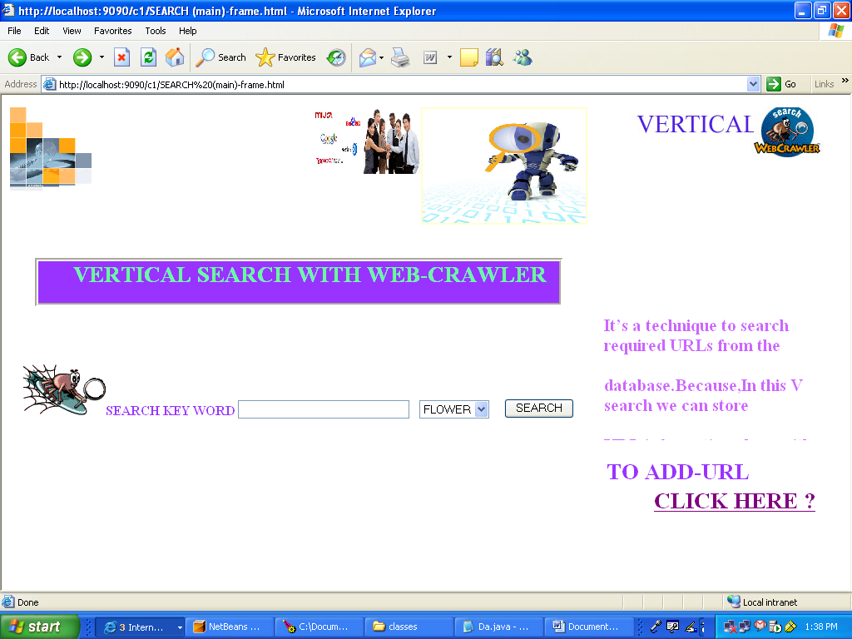
If no field is entered then the following message is displayed.

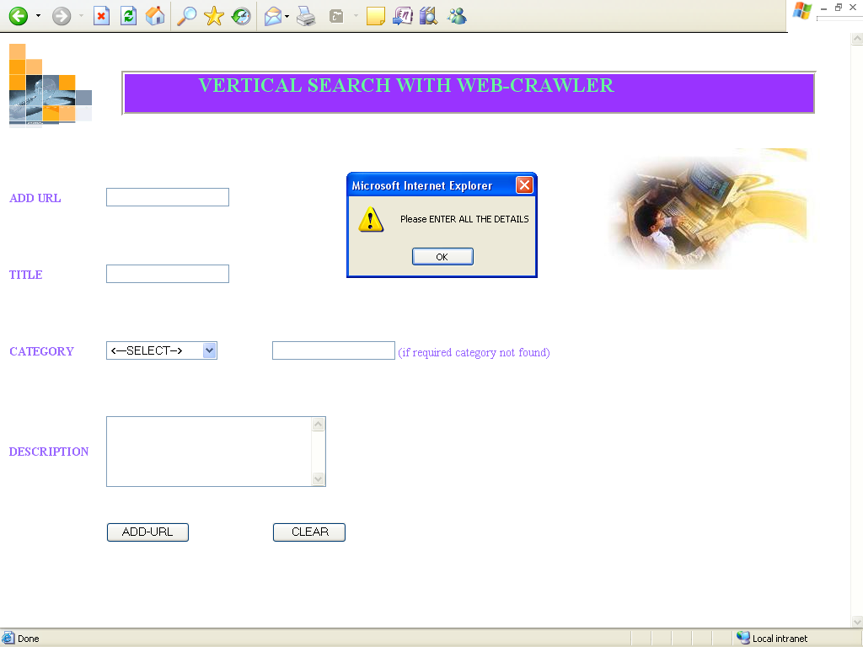
If both the categories were selected then the following message is displayed.

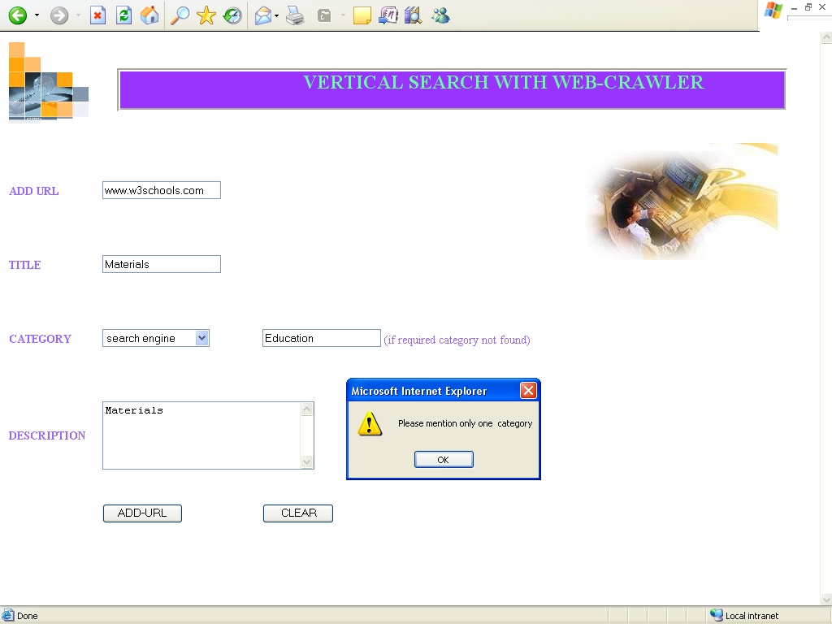
If all the details are not entered then the following message is displayed.

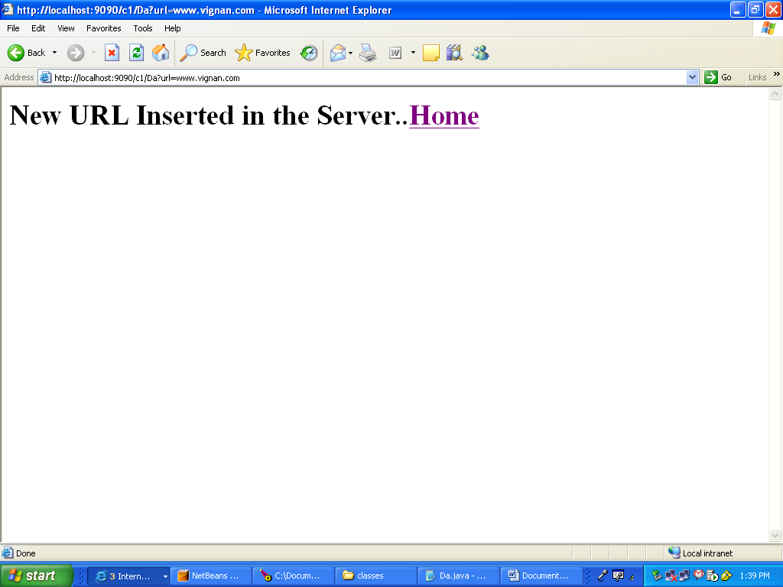
If the user enters correct and complete information then the followed page is displayed.

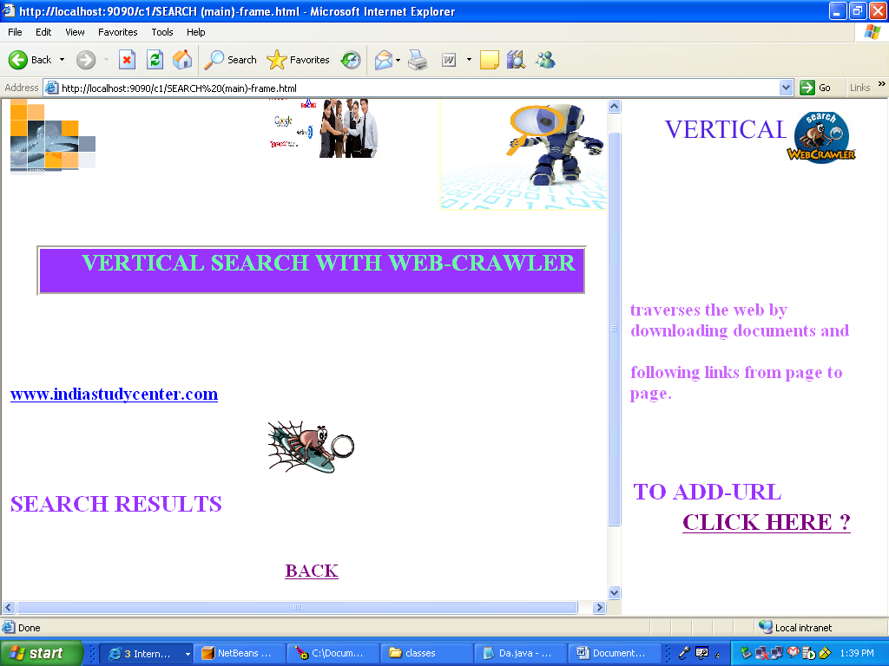

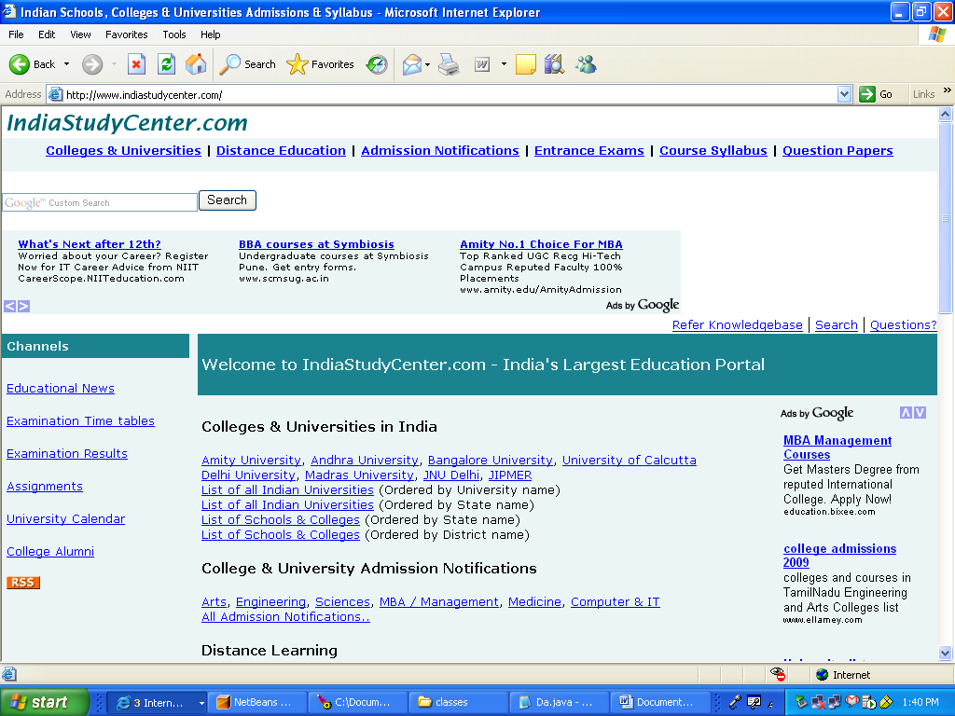

TESTING
TESTING

Testing is the major quality control measure employed during software development. Its basic function is to detect errors in the software. During the requirement analysis and design, the output is a document that is usually textual and non-executable. After the coding phase, computer programs are available that can be executed for testing purposes. This implies that testing not only has to uncover errors introduced during coding, but also errors introduced during the previous phases. Thus the goal of testing is to uncover requirement, design or coding errors in the programs. Consequently, different levels are employed.

The starting point of testing is unit testing. In this a module is tested separately and is often performed by the coder himself simultaneously with the coding of the module. The purpose is to exercise the different parts of the module code to detect coding errors. After this the modules are gradually integrated into subsystems, which are then integrated themselves to eventually from the entire system. During integration of modules, integration testing is performed. The goal of this testing is to detect design errors, while focusing on testing the interconnection between modules.

After the system is put together, system testing is performed. Here the system is tested against the system requirements to see if all the requirements are met and the system performs as specified by the requirements. Finally, acceptance testing is performed to demonstrate to the client, on the real life data of the client, the operation of the system.

For testing to be successful, proper selection of test cases is essential there are two different approaches to selecting test cases – functional testing and structural testing. In functional testing the software or the module to be tested is treated as a black box, and the test cases are decided based on the specifications of the system or the module. For this reason this form of testing is also called “black box testing”. The focus here is on testing the external behavior of the system. In structural testing the test cases are decided based on the logic of the module to be tested. A common approach here is to achieve some type of coverage of the statements in the code. Structural testing is sometimes called “glass box testing”. Often structural testing is used only for lower levels of testing, while functional testing is used for higher levels.

Testing is extremely critical and time consuming activity. It requires proper planning of the overall testing process. Frequently the testing process starts with a test plan. This plan identifies all the testing related activities that must be performed and specifies the schedule, allocates the resources, and specifies guidelines for testing. Then for different test units, a test case specification document is produced, which lists all the different test cases, together with the expected outputs, that will be used for testing. The final output of the testing phase is the test report and the error report, or a set of such reports (one for each unit tested). Each test report contains the set of test cases and the result of executing the code with these test cases. The error report describes the error encountered and the action taken to remove the error.

Types of testing

Testing is again further characterized into three main types namely-
1. White box testing
2. Black box testing
3. Grey box testing

White box ,black box, and grey box testing:

1. Black box testing assumes an external view of the object, one inputs data and one sees only outputs from the test object.
2. White box testing provides an internal view of the test object and its processes.
3. Grey box testing is used almost exclusively by client-server testers or others who use a database as a repository of information, but can also apply to a tester who has to manipulate input or configuration files directly, or perform testing like SQL injection. It can also be used by testers who know the internal workings or algorithm of the software under test and can write tests specifically for the anticipated results.

Verification and validation:
Software testing is used in association with verification and validation (V&V).
1. Verification is the checking of or testing of items, including software, for conformance and consistency with an associated specification.
2. Validation is the process of checking what has been specified is what the user actually wanted.

Levels of testing

1. Unit testing:
It tests the minimal software component or module. Each unit of the software is tested to verify that the detailed design for the unit has been correctly implemented.

2. Integration testing:
Exposes defects in the interfaces and interaction between integrated components or modules.

3. System testing:
Tests an integrated system to verify that it meets its requirements.

4. System integration testing:
Verifies that a system is integrated to any external or third party systems defined in the requirements.

5. Acceptance testing:
It is conducted by the end-user, customer, or client to validate whether or not to accept the product. Acceptance testing may be performed after the testing and before the implementation phase.

6. Alpha testing and Beta testing:
Is simulated or actual operational testing by potential users/customers or an independent test team at the developer’s site. Beta testing versions of the software known as Beta versions are released to a limited audience outside of the company. The software is released to the people so that further testing can ensure the product has bugs.

Code coverage:
Code coverage is inherently a white box testing activity. The target is built with special options or libraries and /or run under a special environment such that every function that is exercised(executed) in the program(s) are mapped black to the function points in the source code. This process allows developers and quality assurance personnel to look for parts of a system that are rarely or never accessed under normal conditions(error handling and the like) and helps and reassure test engineers that the most important conditions(function points) have been tested.

CONCLUSIONS
CONCLUSION

This project “Vertical Search with WebCrawler” searches required result using vertical searching techniques. The search engine will accept the search keywords and will search the web pages for the keywords using some search algorithms.

The advantages of this system are

- They are easy to use and are efficient.

- Rules can be generated that are easy to interpret and understand.

- They scale well for large databases because the tree size is independent of database size.

- Each tuple in the database must be filtered through the tree.

- Trees can be constructed for data with many attributes.

Hence this system is successful in achieving the solution.

SUMMARY OF CONTRIBUTIONS

This project has contributed in the following ways

- The idea is the result of the practical experience of the problem.

- The project has brought out a new requirement.

- The project has shown a worth while problem.

- The question that is aroused is tried to answer and up to some extent successful.

- This has given a new idea for several developers to develop software answering the question.

- There is a large scope of work that can be done on this project.

FUTURE RESEARCH

This project can be extended in following ways
- They can be easily extended by adding new classes.
- Strong Authentication can be provided to restrict the data entry.
- This authentication restricts the population of database with unnecessary data.
- Subcategories can be introduced to further reduce the searching scope.
- Pagerank can be implemented to record frequently visited sites so that retrieving will be faster.

BIBLIOGRAPHY

BIBLIOGRAPHY

1. Object oriented software engineering Bernd Bruegge
Allen H. Dutoit

2. An Integrated approach to Software Engineering
Pankaj jalote

3. UML in 24 hours Joseph Schmulter

4. An Introduction to object Oriented Stephen.R.Schach
System analysis and design with UML

5. Project based software engineering: An Evelyn Stiller, Cathie
Object oriented approach Le Blane

6. Java Complete Reference Herbert Schildt

7. Fundamentals of Database Systems
Elmasri , Navathe, Somayajalu, Gupta

8. Oracle8i Ivan Byros

9. Oracle Complete Reference

